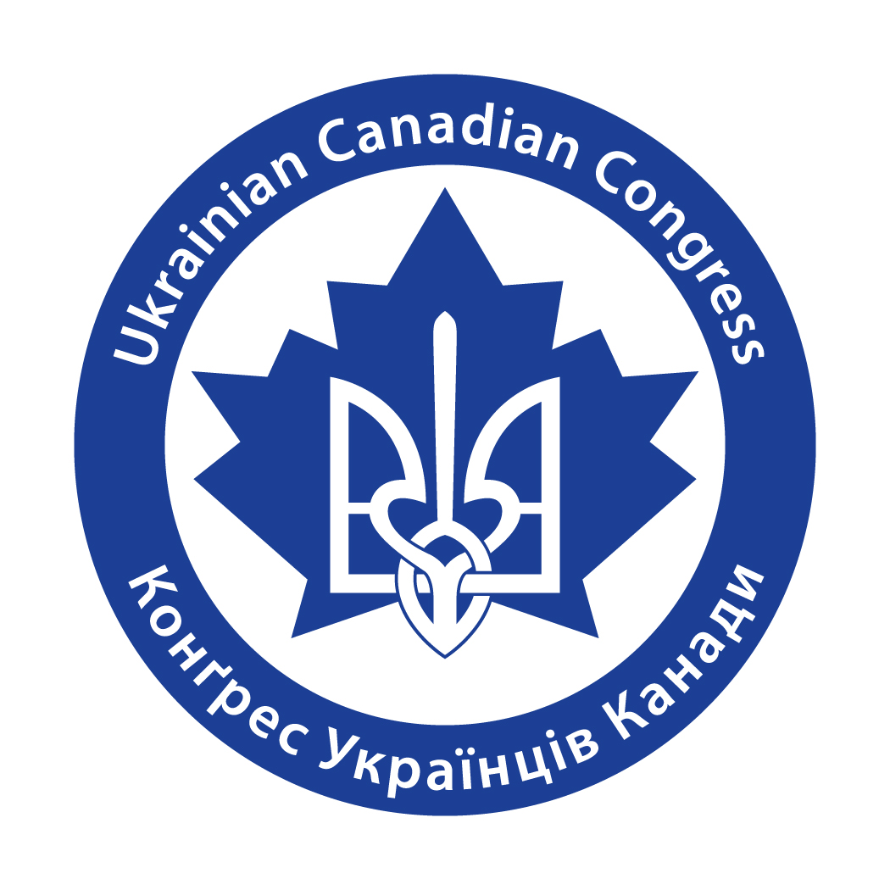

‘A Ukrainian Canadian Tapestry’
‘Weave’ your story here and be a part of the visual display—
A Canada 150 Hamilton & Ukrainian Canadian Congress Hamilton Project
Deadline: September 20, 2017

USE THIS OUTLINE TO WRITE YOUR STORY
Please complete the section that pertains to you. Also complete the section that relates to your spouse, parents and/or grandparents. Please include 2 or 3 pictures for each section you complete. You can complete the package in Ukrainian or English.
Return completed package to: ‘A Ukrainian Canadian Tapestry’,
UCC Hamilton, 1252 Barton Street, Hamilton, On L8H 2V9 OR
complete online at ucchamilton.ca/UkrainianCanadianTapestry.
For further information, please call: Mary Holadyk 905-388-1356 or visit the Ukrainian Canadian Congress Hamilton website ucchamilton.ca.

SECTION A – COMPLETE IF YOU WERE BORN IN UKRAINE

YOUR FULL NAME ______________________________________________
SPOUSE’S FULL NAME ___________________________________________

DID YOU COME TO HAMILTON FROM UKRAINE? ____YES ____NO
IF NO, WHERE DID YOU SETTLE FIRST?______________________________
WHAT VILLAGE, CITY, PROVINCE IN UKRAINE DID YOU COME FROM?
_______________________________________________________
SPOUSE______________________________________________________

WHEN DID YOU LEAVE UKRAINE? WHY?_____________________________
_____________________________________________________________
_____________________________________________________________
WHEN DID YOU COME TO HAMILTON? WHY?________________________
_____________________________________________________________
_____________________________________________________________

‘A Ukrainian Canadian Tapestry’ – 2 –

WHAT IS YOUR OCCUPATION IN HAMILTON?_________________________
_____________________________________________________________

HOW MANY CHILDREN DO YOU HAVE?______________________________

WERE YOU ASSOCIATED WITH ANY UKRAINAIN ORGANIZATIONS IN HAMILTON I.E. CYM, UNO, PLAST, UCC ETC. & IN WHAT CAPACITY_____________________________________________________

ARE YOU A MEMBER OF ONE OF THE UKRAINIAN CHURCHES IN HAMILTON?
____ST. VLADIMIR’S UKRAINIAN ORTHODOX CATHEDRAL
____UKRAINIAN CATHOLIC CHURCH OF THE RESSURECTION
____HOLY SPIRIT UKRAINIAN CATHOLIC CHURCH
____ST. NICHOLAS UKRAINIAN CATHOLIC CHURCH
____OTHER____________________________________________________

Include a special memory or family story here:
________________________________________________________________________________________________________________________________________________________________________________________________________________________________________________________________________________________________________________________________________________________________________________________________________________________________________________________________________________________________________
_______________________________________________________________________________________________________________________________________________________________________________________

A Ukrainian Canadian Tapestry’ – 3 –

SECTION B – COMPLETE IF YOU WERE BORN OUTSIDE OF UKRAINE &
CANADA

YOUR FULL NAME ______________________________________________
SPOUSE’S FULL NAME___________________________________________

WHERE WERE YOU BORN?
_____________________________________________________________
SPOUSE ______________________________________________________

DID YOU SETTLE IN HAMILTON FIRST? ____YES ____NO
IF NO, WHERE DID YOU SETTLE FIRST?______________________________

WHEN & WHY DID YOU COME TO HAMILTON?_______________________
__________________________________________________________________________________________________________________________
_____________________________________________________________

HOW DID YOU MAKE A LIVING IN HAMILTON?_______________________
_____________________________________________________________
_____________________________________________________________

HOW MANY CHILDREN/GRANDCHILDREN DO YOU HAVE?______________

WERE YOU ASSOCIATED WITH ANY UKRAINAIN ORGANIZATIONS IN HAMILTON I.E. CYM, UNO, PLAST, UCC ETC. & IN WHAT CAPACITY_____________________________________________________

ARE YOU A MEMBER OF ONE OF THE UKRAINIAN CHURCHES IN HAMILTON?
____ST. VLADIMIR’S UKRAINIAN ORTHODOX CATHEDRAL
____UKRAINIAN CATHOLIC CHURCH OF THE RESSURECTION
____HOLY SPIRIT UKRAINIAN CATHOLIC CHURCH
____ST. NICHOLAS UKRAINIAN CATHOLIC CHURCH
____OTHER____________________________________________________
A Ukrainian Canadian Tapestry’ – 4 -

Include a special memory or family story here:
________________________________________________________________________________________________________________________________________________________________________________________________________________________________________________________________________________________________________________________________________________________________________________________________________________________________________________________________________________________________________
______________________________________________________________________________________________________________________________________________________________________________________________________________________________________________________________________________________________________________________________________________________________________________

SECTION D – COMPLETE IF YOU WERE BORN IN CANADA

YOUR NAME ___________________________________________________
YOUR PARENT’S NAMES__________________________________________

WHERE IN CANADA WERE YOU BORN?
_____________________________________________________________

WERE YOU BORN IN HAMILTON? IF NO, WHEN & WHY DID YOU COME TO HAMILTON?___________________________________________________
__________________________________________________________________________________________________________________________

HOW D0 YOU MAKE A LIVING IN HAMILTON?_______________________
_____________________________________________________________

HOW MANY CHILDREN/GRANDCHILDREN D0 YOU HAVE?______________
A Ukrainian Canadian Tapestry’ – 5 -

ARE YOU ASSOCIATED WITH ANY UKRAINAIN ORGANIZATIONS IN HAMILTON I.E. CYM, UNO, PLAST, UCC ETC, & IN WHAT CAPACITY?_____________________________________________________

ARE YOU A MEMBER OF ONE OF THE UKRAINIAN CHURCHES IN HAMILTON?
____ST. VLADIMIR’S UKRAINIAN ORTHODOX CATHEDRAL
____UKRAINIAN CATHOLIC CHURCH OF THE RESSURECTION
____HOLY SPIRIT UKRAINIAN CATHOLIC CHURCH
____ST. NICHOLAS UKRAINIAN CATHOLIC CHURCH
____OTHER____________________________________________________

Include a special memory or family story here:
________________________________________________________________________________________________________________________________________________________________________________________________________________________________________________________________________________________________________________________________________________________________________________________________________________________________________________________________________________________________________

YOUR CONTACT INFORMATION:

PHONE NUMBER _______________________________

EMAIL ADDRESS ________________________________

